**SQL Practical Interview Questions**

**Table – EmployeeDetails**

|  |  |  |  |  |
| --- | --- | --- | --- | --- |
| **EmpId** | **FullName** | **ManagerId** | **DateOfJoining** | **City** |
| 121 | John Snow | 321 | 01/31/2019 | Toronto |
| 321 | Walter White | 986 | 01/30/2020 | California |
| 421 | Kuldeep Rana | 876 | 27/11/2021 | New Delhi |

**Table – EmployeeSalary**

|  |  |  |  |
| --- | --- | --- | --- |
| **EmpId** | **Project** | **Salary** | **Variable** |
| 121 | P1 | 8000 | 500 |
| 321 | P2 | 10000 | 1000 |
| 421 | P1 | 12000 | 0 |

1. SQL Query to fetch records that are present in one table but not in another table.
2. SQL query to fetch all the employees who are not working on any project.
3. SQL query to fetch all the Employees from EmployeeDetails who joined in the Year 2020.
4. Fetch all employees from EmployeeDetails who have a salary record in EmployeeSalary.
5. Write an SQL query to fetch a project-wise count of employees.
6. Fetch employee names and salaries even if the salary value is not present for the employee.
7. Write an SQL query to fetch all the Employees who are also managers.
8. Write an SQL query to fetch duplicate records from EmployeeDetails.
9. Write an SQL query to fetch only odd rows from the table.
10. Write a query to find the 3rd highest salary from a table without top or limit keyword.
11. **Write an SQL query to fetch the EmpId and FullName of all the employees working under the Manager with id – ‘986’.**
12. Write an SQL query to fetch the different projects available from the EmployeeSalary table.
13. **Write an SQL query to fetch the count of employees working in project ‘P1’.**
14. Write an SQL query to find the maximum, minimum, and average salary of the employees.
15. **Write an SQL query to find the employee id whose salary lies in the range of 9000 and 15000.**
16. **Write an SQL query to fetch those employees who live in Toronto and work under the manager with ManagerId – 321.**
17. Write an SQL query to**f**etch all the employees who either live in California or work under a manager with ManagerId – 321.
18. **Write an SQL query to fetch all those employees who work on Projects other than P1.**
19. Write an SQL query to display the total salary of each employee adding the Salary with Variable value.
20. **Write an SQL query to fetch the employees whose name begins with any two characters, followed by a text “hn” and ends with any sequence of characters.**
21. Write an SQL query to fetch all the EmpIds which are present in either of the tables – ‘EmployeeDetails’ and ‘EmployeeSalary’.
22. **Write an SQL query to fetch common records between two tables.**  
    Ans. SQL Server – Using INTERSECT operator-
23. Write an SQL query to fetch records that are present in one table but not in another table. **Ans. SQL Server – Using MINUS- operator-**
24. **Write an SQL query to fetch the EmpIds that are present in both the tables –  ‘EmployeeDetails’ and ‘EmployeeSalary.**
25. Write an SQL query to fetch the EmpIds that are present in EmployeeDetails but not in EmployeeSalary. **Using subquery-**
26. **Write an SQL query to fetch the employee’s full names and replace the space with ‘-’.**  
    Ans. Using the ‘Replace’ function-
27. Write an SQL query to fetch the position of a given character(s) in a field. **Ans. Using the ‘Instr’ function-**
28. **Write an SQL query to display both the EmpId and ManagerId together.**  
    Ans. Here we can use the CONCAT command.
29. Write a query to fetch only the first name(string before space) from the FullName column of the EmployeeDetails table. **Ans. In this question, we are required to first fetch the location of the space character in the FullName field and then extract the first name out of the FullName field.  
      
    For finding the location we will use the LOCATE method in MySQL and CHARINDEX in SQL SERVER and for fetching the string before space, we will use the SUBSTRING OR MID method.  
      
    MySQL – using MID**
30. **Write an SQL query to uppercase the name of the employee and lowercase the city values.**
31. **Write an SQL query to find the count of the total occurrences of a particular character – ‘n’ in the FullName field.**
32. **Write an SQL query to find the current date-time.**
33. **Write an SQL query to fetch all the Employee** details from the **EmployeeDetails table who joined in the Year 2020.**
34. **Write an SQL query to fetch all employee records from the EmployeeDetails table who have a salary record in the EmployeeSalary table.**
35. **Write an SQL query to fetch the project-wise count of employees sorted by project’s count in descending order.**
36. **Write a query to fetch employee names and salary records. Display the employee details even if the salary record is not present for the employee.**
37. **Write an SQL query to fetch all the Employees who are also managers from the EmployeeDetails table.**
38. **Write an SQL query to fetch duplicate records from EmployeeDetails (without considering the primary key – EmpId).**
39. **Write an SQL query to remove duplicates from a table without using a temporary table.**
40. **Write an SQL query to fetch only odd rows from the table.**
41. **Write an SQL query to create a new table with data and structure copied from another table.**
42. **Write an SQL query to create an empty table with the same structure as some other table.**
43. **Write an SQL query to find the nth highest salary from a table.**
44. **Write SQL query to find the 3rd highest salary from a table**

**Patients Table**

|  |  |  |  |  |  |  |  |  |  |
| --- | --- | --- | --- | --- | --- | --- | --- | --- | --- |
| Patient ID | Patient Name | Sex | Age | Address | Postal Code | State | Country | RegDate | DoctorID |
| 01 | Sheela | F | 23 | Flat no 201, Vasavi Heights, Yakutapura | 500023 | Telangana | India | 03/03/2020 | 142 |
| 02 | Rehan | M | 21 | Building no 2, Yelahanka | 560063 | Karnataka | India | 13/11/2020 | 211 |
| 03 | Anay | M | 56 | H No 1, Panipat | 132140 | Haryana | India | 12/12/2021 | 142 |
| 04 | Mahira | F | 42 | House no 12, Gandhinagar | 382421 | Gujarat | India | 28/01/2022 | 345 |
| 05 | Nishant | M | 12 | Sunflower Heights, Thane |  |  |  |  |  |

**PatientsCheckup Table**

|  |  |  |  |
| --- | --- | --- | --- |
| Patient ID | BP | Weight | Consultation Fees |
| 01 | 121/80 | 67 | 300 |
| 02 | 142/76 | 78 | 400 |
| 03 | 151/75 | 55 | 300 |
| 04 | 160/81 | 61 | 550 |
| 05 | 143/67 | 78 | 700 |

### Write a SQL query to fetch the PatientName in uppercase and state as lowercase. Also use the ALIAS name for the result-set as PatName and NewState.

### Find the Nth highest consultation fees from the PatientsCheckup table

### Write a query to fetch top N records ordered by ConsultationFees.

### Write a query to retrieve the list of patients from the same state.

### Write a query to retrieve two minimum and maximum consultation fees from the PatientsCheckup Table.

### Write a query to fetch patient details along with the weight fees, even if the details are missing.

### Write a SQL query to fetch doctor wise count of patients sorted by the doctors

### Write a SQL query to fetch the first and last record of the Patients table.

### Write a SQL query to fetch consultation fees – wise count and sort them in descending order.

### Write a SQL query to retrieve patient details from the Patients table who have a weight in the PatientsCheckup table.

### Write a SQL query to retrieve the last 2 records from the Patients table.

### Write a SQL query  to find all the patients who joined in the year 2022.

### Write a query to find those patients who have paid consultation fees between 400 to 700.

### Write a query to add email validation to your database.

### Write a SQL query to fetch details of all patients excluding patients with name  “Sheela” and “Anay”.

### Write a query to retrieve the first three characters of  PatientName from the Patients table.

### Write a query to fetch PatientIDs  which are present in:

### Write a query to find the number of patients whose RegDate is between 01/04/2021 to 31/12/2022 and are grouped according to state.

### Write a query to fetch all records from the Patients table; ordered by PatientName in ascending order, State in descending order.

### 

### Lists the number of customers in each country. Only include countries with more than 5 customers:

### Lists the number of customers in each country, sorted high to low (Only include countries with more than 5 customers):

### "Orders" table

### 

### "Employees" table

### 

### Lists the employees that have registered more than 10 orders

### Lists if the employees "Davolio" or "Fuller" have registered more than 25 orders:

### "Orders" table

### 

### "Shippers" table:

### 

1. Lists the number of orders sent by each shipper

"Products" table

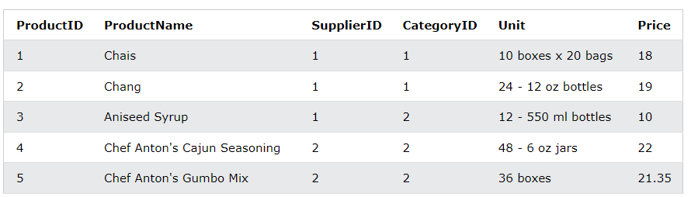

"Suppliers" table:

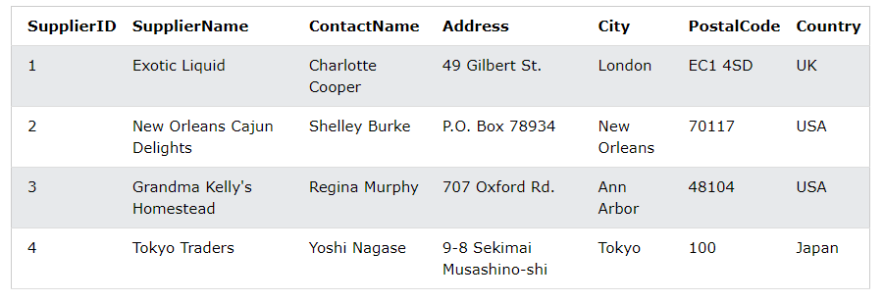

1. Lists the suppliers with a product price less than 20 by using SQL Exists.
2. Lists the suppliers with a product price equal to 22 by using SQL Exists.

**Students**

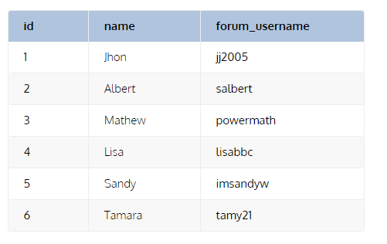

**Comments**

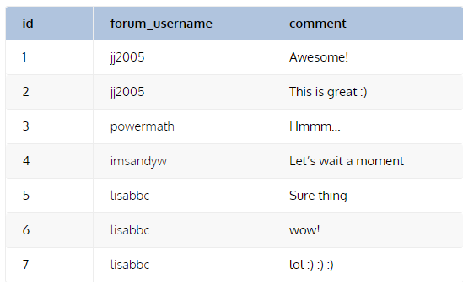

1. Write a SQL query to know the actual student name for each of the comments
2. Write a query to display all the records of the Student table that matched and non matched too.
3. Write a query to display all the records of the Comments table that matched and non matched too.
4. Write a query to display the Cartesian product of student and comment table.

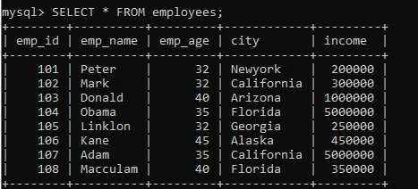

1. Execute the following query that uses the COUNT(expression) function to calculates the total number of employees name available in the table:
2. Execute the following statement that returns all rows from the employee table and WHERE clause specifies the rows whose value in the column emp_age is greater than 32:
3. This statement uses the COUNT(distinct expression) function that counts the Non-Null and distinct rows in the column emp_age:
4. By use the count() function with the GROUP BY clause that returns the count of the element in each group. For example, the following statement returns the number of employee in each city:
5. Use ORDER BY and Having clause with the count() function. Execute the following statement that gives the employee name who has at least two age same and sorts them based on the count result:

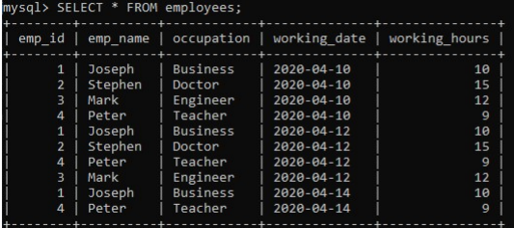

1. Write a query that calculates the total number of working hours of all employees in the table:
2. Write a query used to return the result based on the condition specified in the WHERE clause. Execute the following query to calculate the total working hours of employees whose working_hours >= 12.
3. Write a query to use the SUM() function with the GROUP BY clause to return the total summed value for each group. For example, this statement calculates the total working hours of each employee by using the SUM() function with the GROUP BY clause, as shown in the following query:
4. Use having clause to execute the following statement that calculates the working hours of all employees, grouping them based on their occupation and returns the result whose Total_working_hours>24.
5. Uses the DISTINCT keyword to remove the duplicate rows from the column name. This clause can also be used with sum() function to return the total summed value of a Unique number of records present in the table.

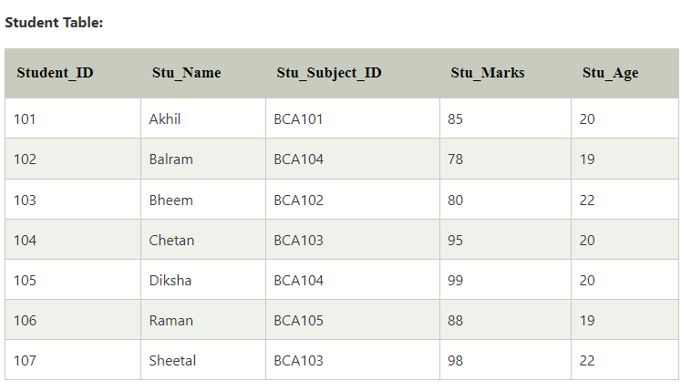

**Subject.**

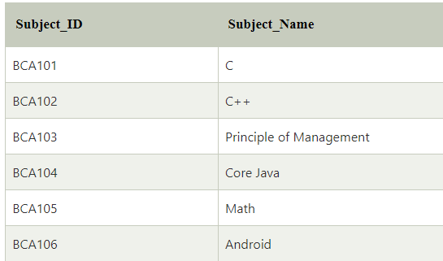

1. Write a query shows the Subject_Name of those subjects whose Subject_ID is BCA103 and BCA106:

### Write a query in SQL to find the minimum and maximum number from the integer column

### Write a query to access the first record from the SQL table?

### Write a query to access the first Nth rows from the table?

### Write a query in SQL to create a new table with the same data and structure as an existing table.

### Write a query in SQL to find the second-highest value of an integer column from the table?

### Write a query shows the second-highest marks from the student table:

### Write query shows the record of the three highest marks from the student table:

### Write an SQL query to fetch the Stu_Name and Stu_Marks of those students whose age is 20.

### Write a query to show the maximum marks of each subject.

### Write a query to show all the record of those students whose Marks is greater than 82 and age is 22

### Write a query to show the record of those students whose name begins with the 'm' character.

### Write an SQL query to show the unique values of Stu_Age from the student table:

### Write query shows the first two characters of Stu_Name from the Student table:

### Write query creates the View of those students whose Marks is greater than 85 from the Student table:

### Write a query finds the average of marks of Student table: